Design Document

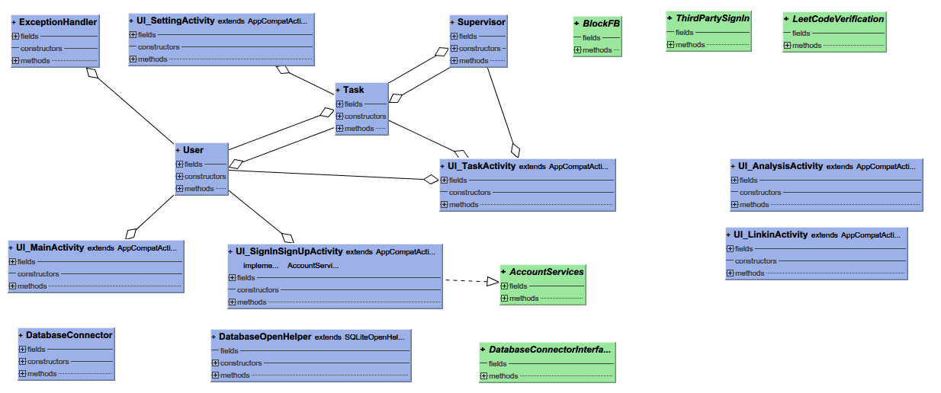

Step 1. Screens

1. User Registration / Login

When users open the app for the first time, they are required to create an account to log in. Users provide a username and password, then link the app with Leetcode (password of Leetcode will only be stored locally, not in the server’s database).

If an account has already been logged in on this device, the app will remember the account. But if the user would like to switch accounts there is a login page for him to log in again.

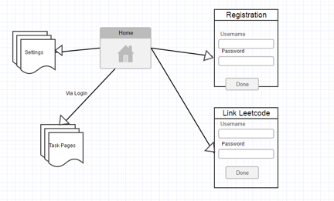

2. Main Page - Starting a task

The central page is for starting a concentration task and viewing current Leetcode progress. Main page has a big ‘START’ button and once clicked there is no way back until the user is able to finish the Leetcode progress and the system verifies this. After hitting the start button user will be directed to the task page.

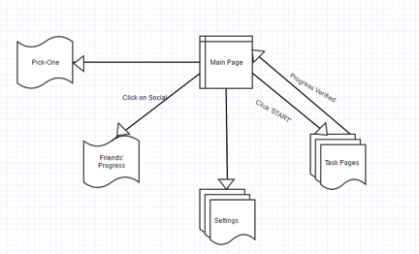

3. Task Page – When In Progress

When the user starts a Leetcode task this page will display his current status like time spent and acceptance / submission progress. There is a big ‘VERIFY TASK’ button and when clicked the system will grab data from Leetcode website using user’s account and verify if the acceptance number is enough. Only when verified the page can exit and Facebook is no longer blocked.

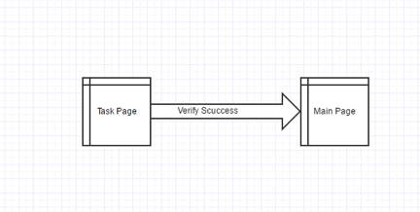

4. Settings and Information

From both Main page and Task page the user can access ‘Settings’ by clicking on the left top corner of the app. The settings include multiple pages in which detailed configuration is allowed, like number of problems to be solved each time, websites to be blocked, etc.

Also there’s an information or help page providing necessary specification and guidance for the application.

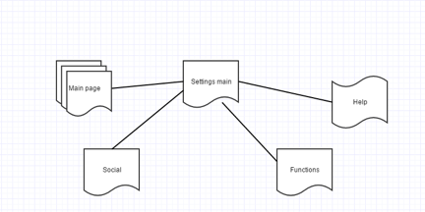

5. Pick-One

The pick-one-problem page displays a new Leetcode problem when user shakes the phone. It’s an interesting feature when the user wants to get started but has no idea what to begin with. This page can be accessed via the main page.

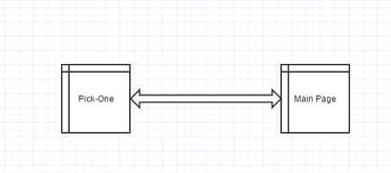

Step 3. Content Provider

Every time there is a user sign up in the app, the TB_FC_Account table will record the information and if the user uses the leetCode username and password to login, the TB_LC_Account table will record the information. The users are separated into two groups and it will be helpful for the search.

Every time the user clicks the ‘start’ button, it will call the insert into TB_RECORD_DETAIL method, and we will record the time he start the process, the location where he is doing his job, the goal he set, and the date. And after he submits his job and it will update the record and set the end time of this process. And at the meantime, it will update the TB_RECORD_DETAIL table, and record the problems users have solved.

Server database : MySQL

Every day the TB_RECORD_STAT will be updated and keep the pace of the database of the devices.

The implemented methods:

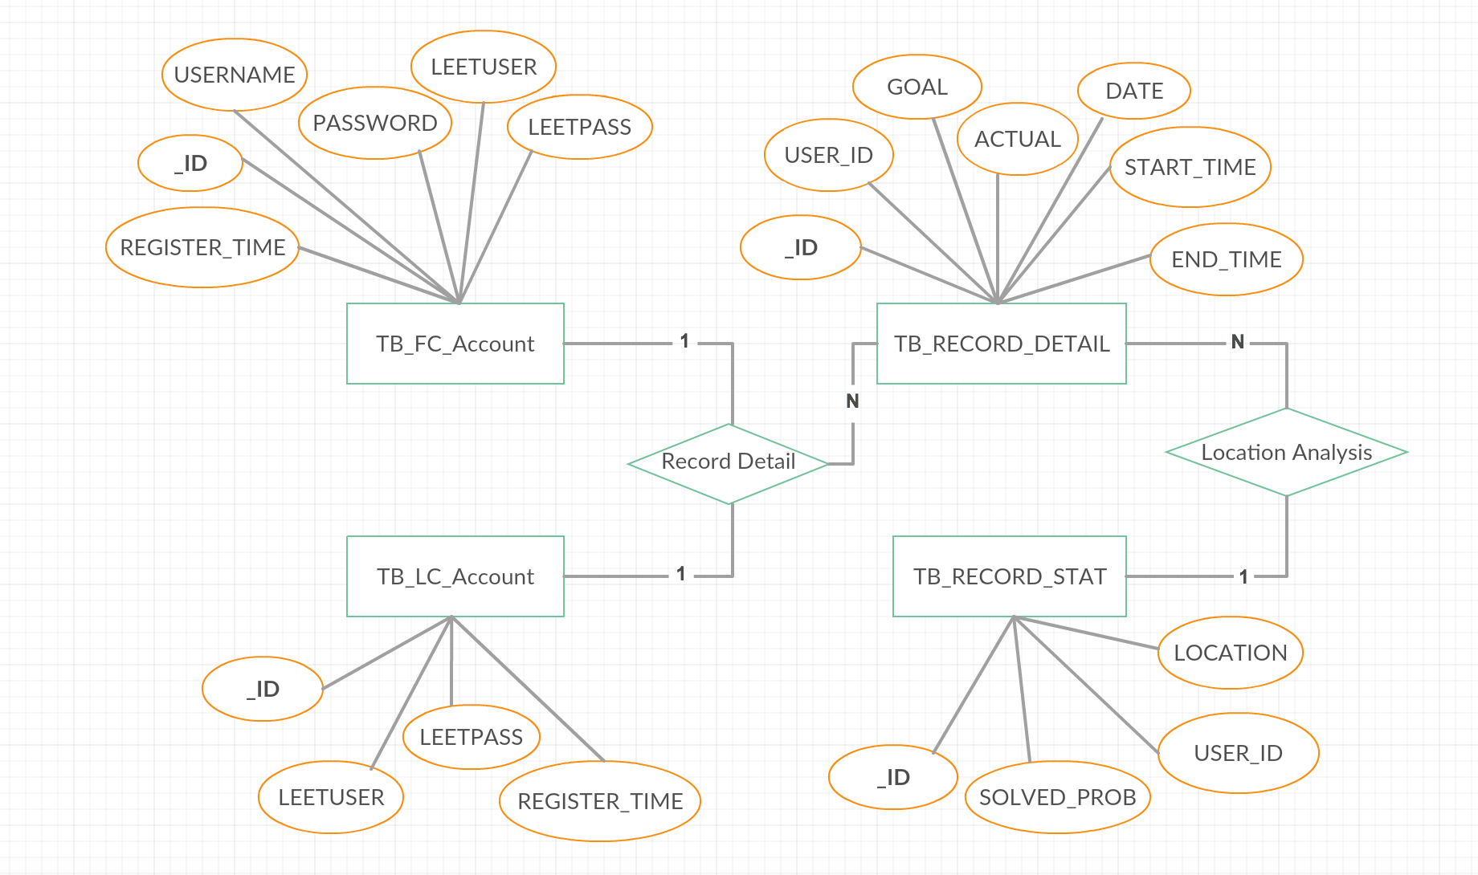

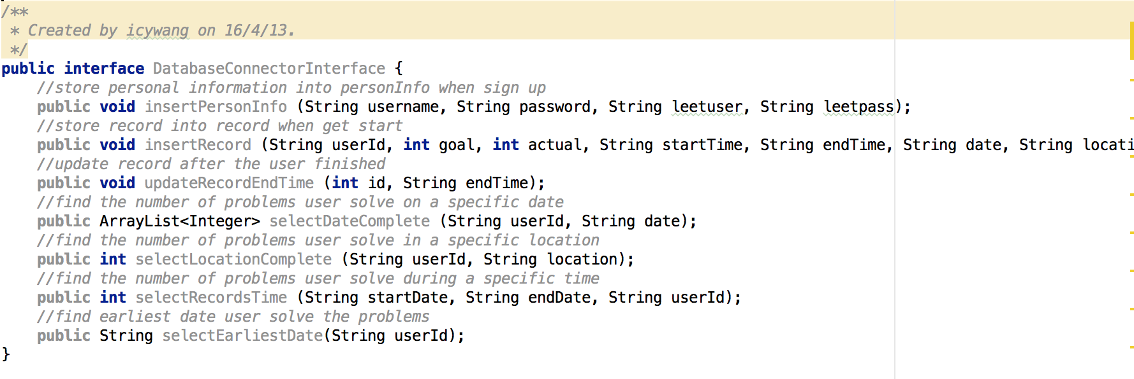

Step 4. Application Tier

There are three entities involved in the lifetime of the app: Users, Tasks and Supervisors. User objects are created when logged in. A User interacts with a Task by setting up and starting it. Once a Task is started, its Supervisor is also created and the User interacts with Supervisor through Task.

When a Task is going on, the User starting coding and when finishing he can click the ‘Verify’ button and the Task will initiate a verify request with the Supervisor. When Supervisor has finished verifying, the result is sent to Task and presented to the User.

The use case sequence diagram is like this:

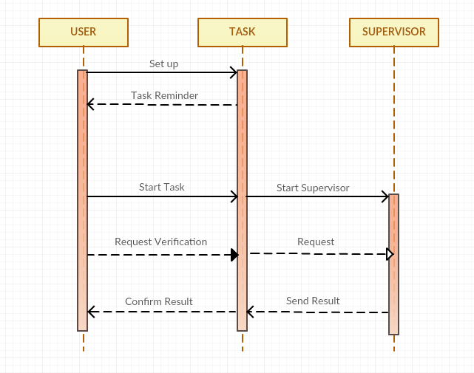

The three entities are exposed to the application tier like this: the User is created in the Login page. In the Settings page a task is configured and on Homepage the User starts it. Afterwards, the user is redirected to the Task page and on this page he interacts with the Task / Supervisor using the button.

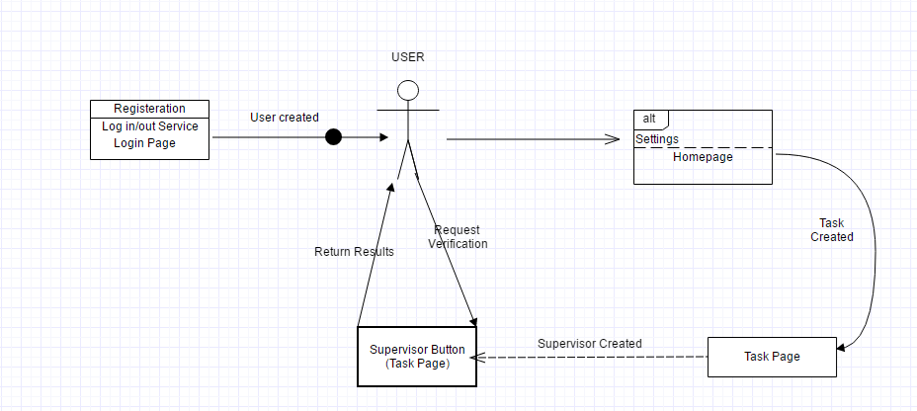

Step 5. Integration Tier

There are 4 different services provided in the application and they are separated out by remote / local interactions.

The local services are:

Third-party connection service, responsible for third-party account registration or login.

Target process blocking service, used to block access to our target apps when focus tasks are started.

The remote services are:

Account-related service (provided by the application server)

Leetcode data extraction service, responsible for grabbing user’s accomplishment data from Leetcode’s server.

